Launch Linux EC2 instances in two regions using a single Terraform file.

An active AWS account.

Terraform installed on your local machine.

AWS CLI configured with necessary credentials (access key and secret key).

Terraform Configuration

Create a file named main.tf and add the following configuration.

# Define the default provider (us-east-1 in this example)
provider "aws" {
region = "us-east-1"
}

# Define a second provider with an alias (us-west-2 in this example)
provider "aws" {
alias = "us-west-2"
region = "us-west-2"
}

# Define a variable for AMIs since AMIs are region-specific
variable "ami_ids" {
type = map(string)
default = {
"us-east-1" = "ami-0c55b159cbfafe1f0" # Example AMI ID for us-east-1 (Amazon Linux 2 AMI) - use a current one
"us-west-2" = "ami-0aa8fc2422063977a" # Example AMI ID for us-west-2 (Amazon Linux 2 AMI) - use a current one
}
}

# Create an EC2 instance in us-east-1 using the default provider
resource "aws_instance" "instance_east" {
ami = var.ami_ids["us-east-1"]
instance_type = "t2.micro" # Free tier eligible type
tags = {
Name = "East-Region-Instance"
}
}

# Create an EC2 instance in us-west-2 using the aliased provider
resource "aws_instance" "instance_west" {
provider = aws.us-west-2
ami = var.ami_ids["us-west-2"]
instance_type = "t2.micro" # Free tier eligible type
tags = {
Name = "West-Region-Instance"
}
}

# Output public IPs for verification
output "east_instance_public_ip" {
value = aws_instance.instance_east.public_ip
}

output "west_instance_public_ip" {
value = aws_instance.instance_west.public_ip
}

Steps to Deploy

Initialize Terraform: Open your terminal, navigate to the directory containing your main.tf file, and run terraform init to download the necessary provider plugins.

Plan the deployment: Run terraform plan to preview the resources that Terraform will create.

Apply the configuration: If the plan looks correct, run terraform apply and type yes when prompted to create the EC2 instances in both regions.

Verify the deployment: Log in to your AWS Management Console to verify that the instances are running in the us-east-1 and us-west-2 regions, or check the output IPs in your terminal.

Create AWS EC2 using Terraform

Amazon EC2 is a web service presented by Amazon Web Services (AWS) that gives resizable compute capacity in the cloud. It permits clients to run virtual servers, known as EC2 instances, in a versatile and flexible manner. EC2 instances can be handily provisioned and designed to meet changing jobs, making them suitable for a wide range of applications.

Terraform

Terraform is an open-source Infrastructure as Code (IaC) apparatus created by HashiCorp. It empowers clients to characterize and arrange foundations utilizing a revelatory setup language. With Terraform, clients can oversee assets across numerous cloud suppliers, including AWS, Sky Blue, and Google Cloud Stage, as well as on-premises conditions.

Declarative Configuration: Depict the ideal infrastructure state in a configuration file (written in HashiCorp Design Language - HCL).

Support for Multi-Clouds: Arrangement and oversee assets across different cloud suppliers with a solitary arrangement of design documents.

Version Control: Infrastructure code can be formed, permitting joint effort and change following.

Dependency management: The order of resource creation and their interdependencies are automatically managed by Terraform.

Plan and Apply: Terraform gives an planning phase (terraform plan) to review changes prior to applying them (terraform apply).

Now install and configuring Terraform

Go to browser and search for terraform official site in that official site is there terraform download link as shown in below commands and Open a terminal or command prompt and run the command terraform version to verify the installation.

sudo yum install -y yum-utils shadow-utils
sudo yum-config-manager --add-repo https://rpm.releases.hashicorp.com/AmazonLinux/hashicorp.repo
sudo yum -y install terraform

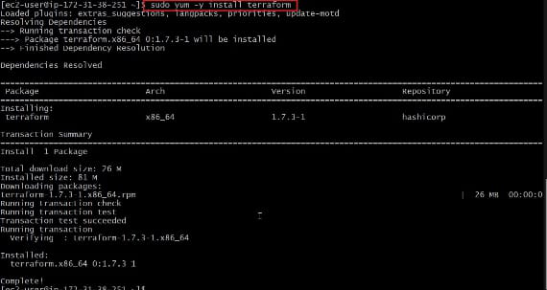

Now after installed and configured terraform, Now make a new directory and navigate to it, Terraform file must should be save with filename.tf.

Additional files can be created to modularize your code or to store provider-specific configurations. You will define the infrastructure resources you want to create in the main.tf file, such as VPCs, subnets, security groups, and AWS EC2 terraform instances.

Terraforms declarative language is used to define each resource, allowing you to declare the desired state of the resource.

Steps To Create AWS EC2 Instance and Attach EBS To EC2 Using Terraform

Step 1 : Mention the provider and region in which you want to create the AWS resources in provider.tf file.

provider "aws" {
region = "us-east-1"
}

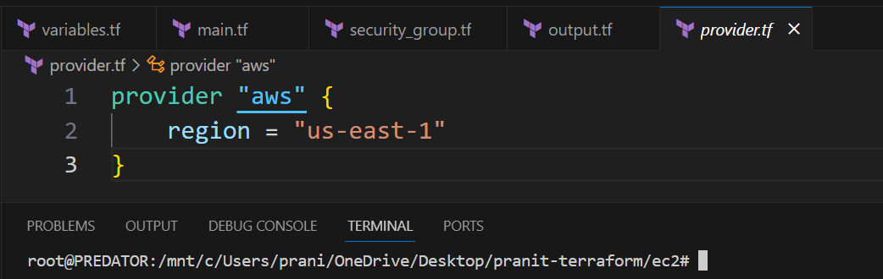

Step 2 : Then create a variables file where you have to mention all the variables that is EC2 instance going to use such as ami-id , instance type , server port , ssh port in variables.tf file.

variable "instance_type" {
description = "This describes the instance type"
type = string
default = "t2.micro"
}
variable "ami_id" {
description = "This describes the ami image"
type = string
default = "ami-01c647eace872fc02"
}
variable "server_port" {
description = "Server use this port for http requests"
type = number
default = 80
}
variable "ssh_port" {
description = "Describes the ssh port"
type = number
default = 22
}
variable "availability_zone" {
default = "us-east-1a"
}

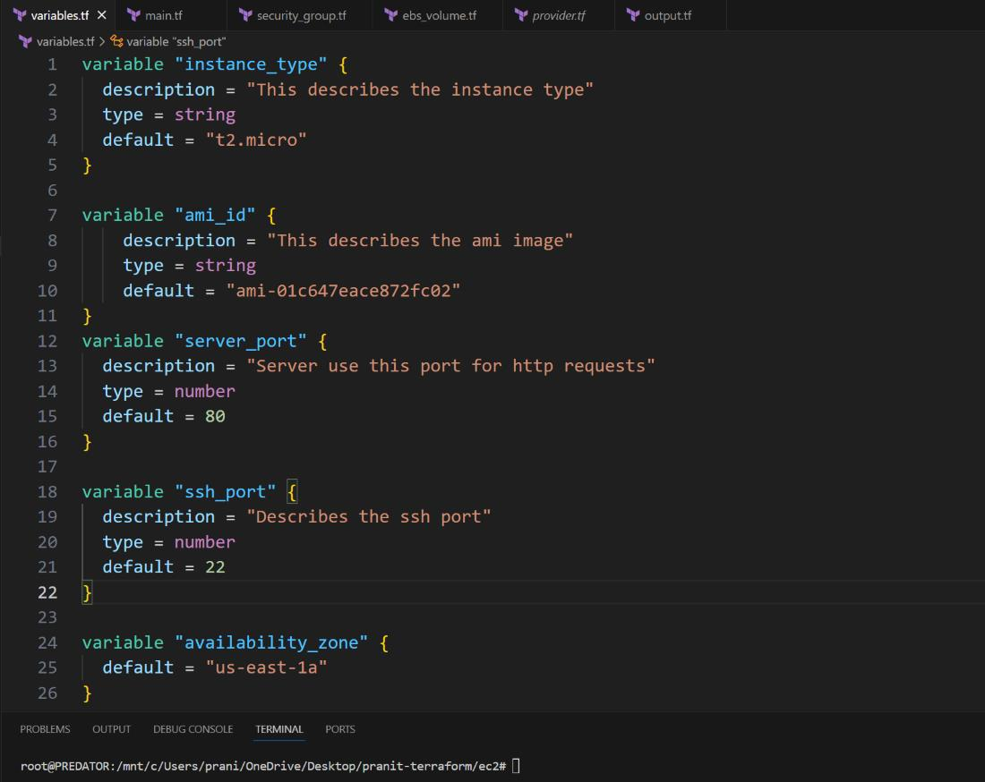

Step 3 : Then create a file where you can define the security group configurations in security_group.tf file.

resource "aws_security_group" "instance" {
name = "terraform-SG"
ingress {
from_port = var.server_port
to_port = var.server_port
protocol = "tcp"
cidr_blocks = ["0.0.0.0/0"]
}
ingress {
from_port = var.ssh_port
to_port = var.ssh_port
protocol = "tcp"
cidr_blocks = ["0.0.0.0/0"]
}
egress {
from_port = 0
to_port = 0
protocol = "-1"
cidr_blocks = ["0.0.0.0/0"]
}
}

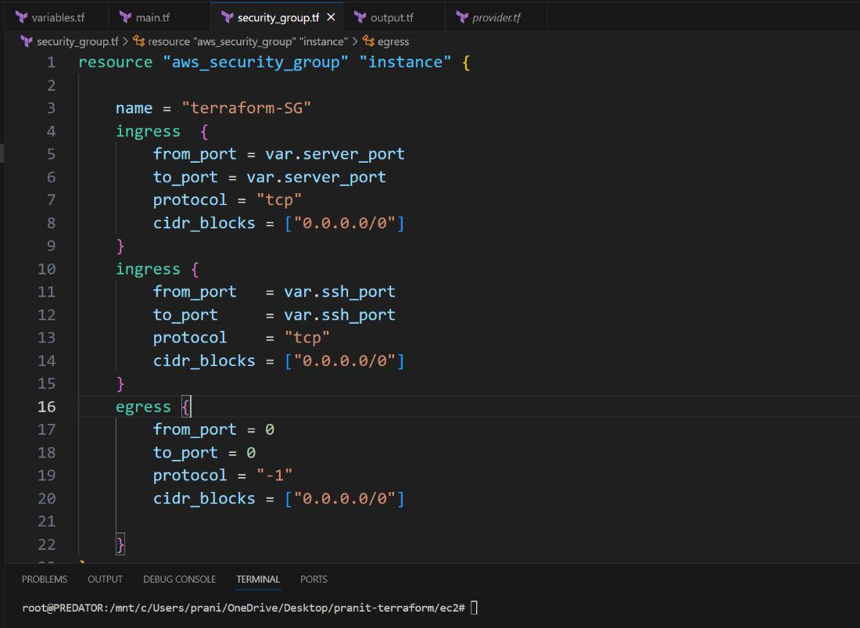

Step 4: Then create aws instance resource . Here mentions the variables and also in the user data write a script that will install httpd service and index.html on the EC2 instance in main.tf terraform file.

resource "aws_instance" "server" {
ami = var.ami_id
instance_type = var.instance_type
vpc_security_group_ids = [ aws_security_group.instance.id ]
availability_zone = var.availability_zone
tags = {
Name = "EC2-Server"
}
user_data = <<-EOF
#!/bin/bash
sudo yum update -y
sudo yum install httpd -y
sudo systemctl start httpd
sudo systemctl enable httpd
echo "Terraform is easy!!!" > /var/www/html/index.html
EOF
user_data_replace_on_change = true
}

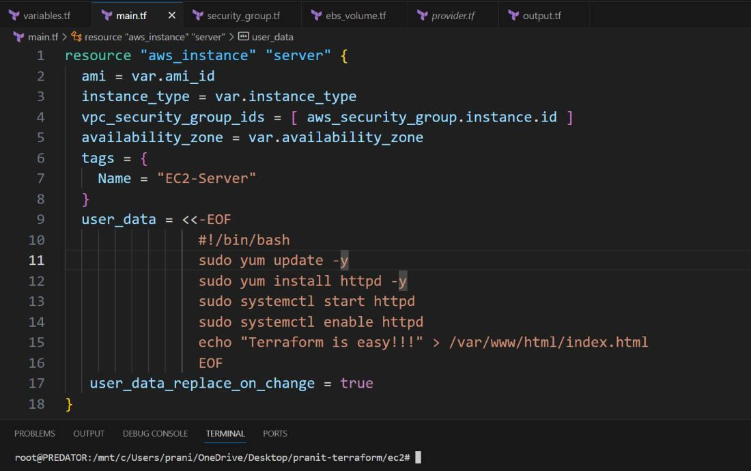

Step 5: Create an EBS volume . Then attach it to the EC2 instance in ebs_volume.tf file.

resource "aws_volume_attachment" "ebs_att" {
device_name = "/dev/sdh"
volume_id = aws_ebs_volume.ebs_vol.id
instance_id = aws_instance.server.id
}
resource "aws_ebs_volume" "ebs_vol" {
availability_zone = var.availability_zone
size = 1
}

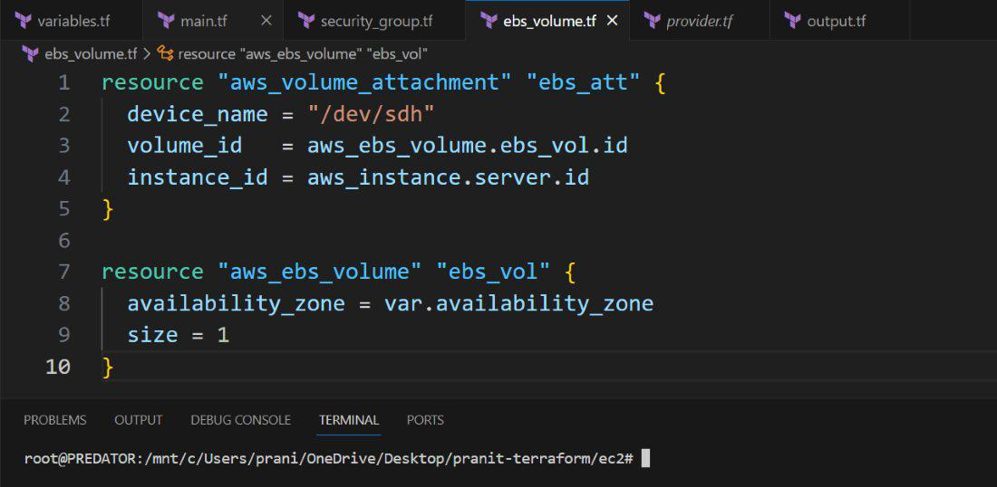

Step 6 : Create a output file which will give the public IP of the EC2 instance as output in output.tf terraform file.

output "public_ip" {
description = "The public IP address of the web server"
value = aws_instance.server.public_ip
}

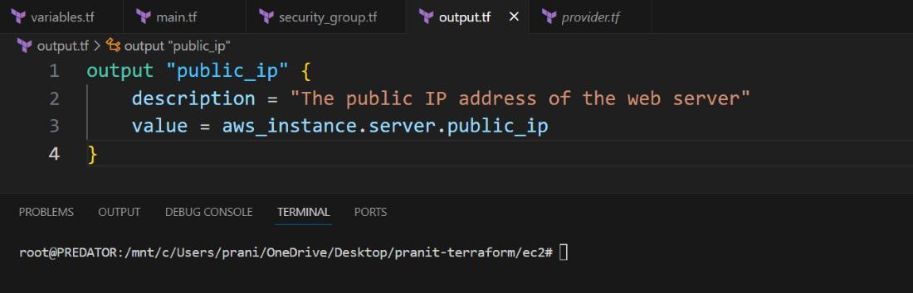

Step 7 : Then run all the terraform files using the below commands one by one .

terraform init

The following command shows the definition of the Terrform files that you provided.

terraform plan

The following command helps in executing the configured/defined tasks.

terraform apply

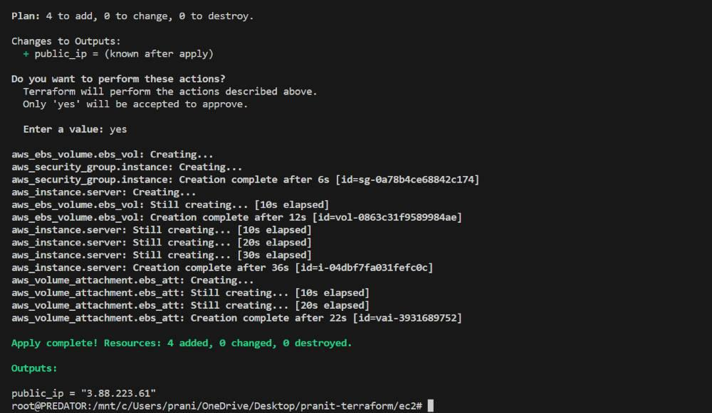

Step 8 : Check on AWS console whether the EBS volume is attached to the EC2 instance or not .

Step 9 : Then connect the public IP to see the website.

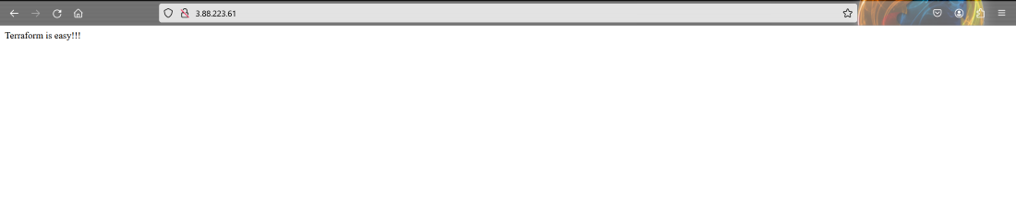

Navigate to Services -> IAM -> Access management -> Users. Click on the Add users button.
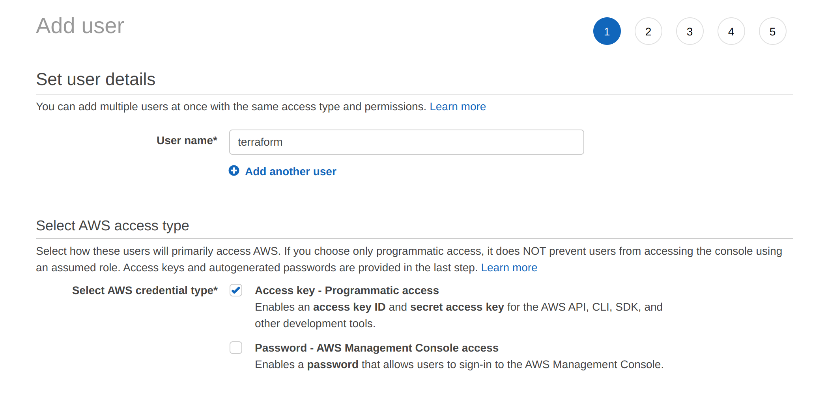

Select Attach existing policies directly. Attach the AdministratorAccess policy to this user.
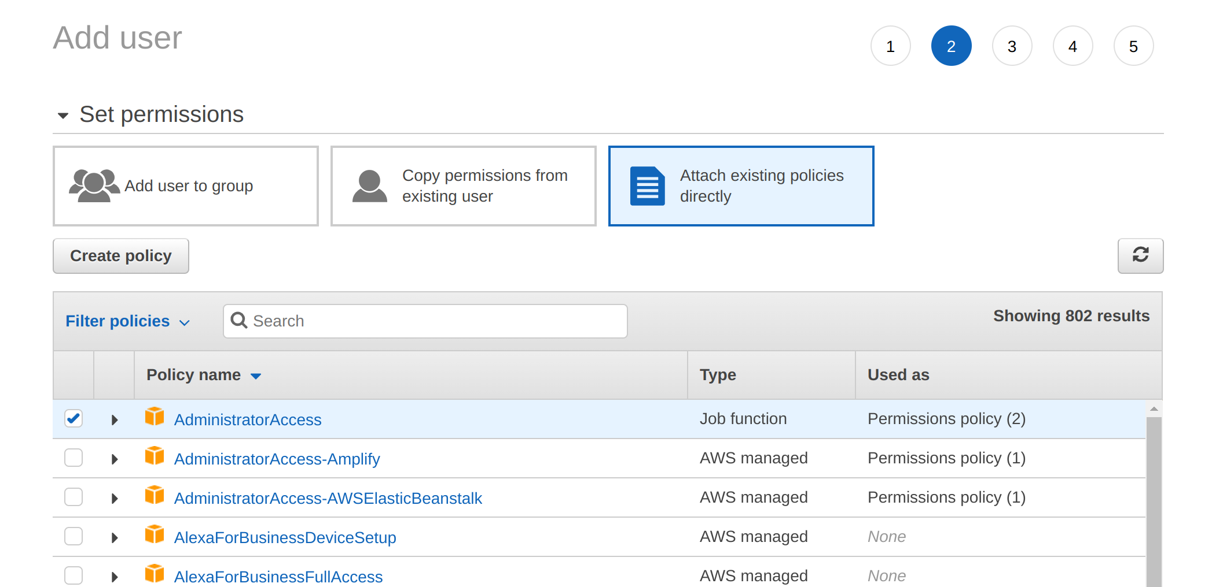

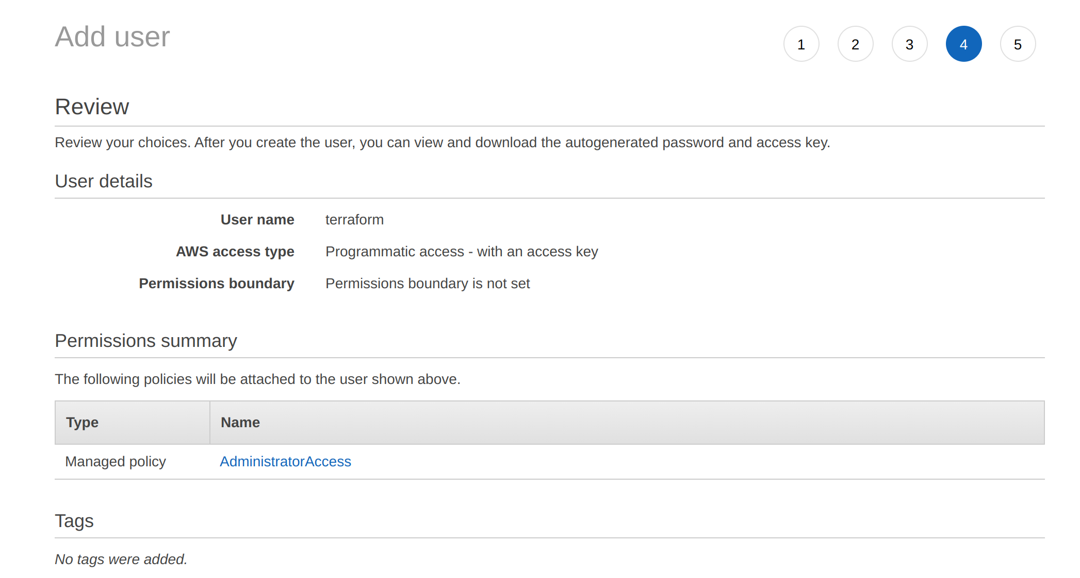

Click on Create user. Congrats! terraform user created. Save the access key ID and secret access key to use later.
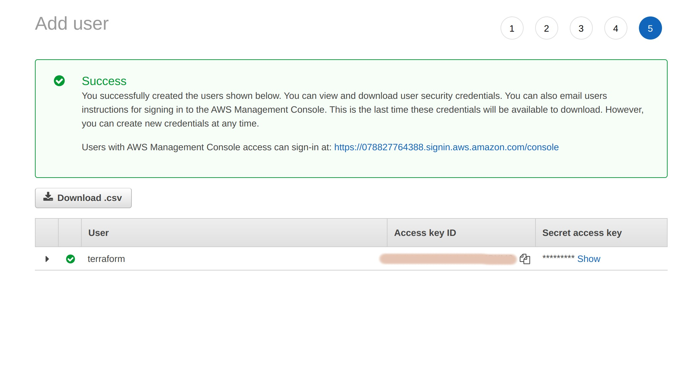

Create a terraform file. The extension for a terraform file is .tf. I have named the file launchEC2.tf.
Configure the file to launch an ec2 instance. Before moving on, I want to tell you that some arguments are optional, and some are required. For example, mentioning the availability zone is optional, but the AMI ID is required. If the optional arguments aren't specified, they will be configured using the default AWS settings.

SELECT PROVIDER:
It is aws instance. Therefore we will specify; aws as the provider
provider "aws"{
}

SELECT REGION
Select a region of our choice
provider "aws"{
region = "ap-south-1" #Mumbai region
}

PROVIDER CREDENTIALS:

You may use various approaches to log in to AWS. We'll be storing credentials in the file itself. Not a secure way. But we'll do it anyways because it's a pretty straightforward approach.
We'll use the access and secret key of the terraform user we created previously. I am using an alt text here, but you should mention the authentic keys.
provider "aws"{
region = "ap-south-1"
access_key = "abc" #Provide access key of "terraform" user
secret_key = "xyz" #Provide secret key of "terraform" user
}

CREATE RESOURCES:
Now, you have to specify what AWS resource you would like to create and what name should be given to it. We want to create an AWS instance named test-ec2-instance.

provider "aws"{
region = "ap-south-1"
access_key = "abc"
secret_key = "xyz"
}
resource "aws_instance" "test-ec2-instance"{
}

CONFIGURE IMAGE ID:

Specify the amazon machine image(AMI) id of the instance. I am using Amazon Linux 2 Kernel 5.10 AMI 2.0.20221210.1 x86_64 HVM gp2 image, so I have to mention the AMI ID corresponding to this AMI.
The one thing that you should know is that AMI ID is region specific. This means AMI ID will be different in every region. As you can see below, the ID for Amazon Linux 2 Kernel 5.10 AMI 2.0.20221210.1 x86_64 HVM gp2 AMI is ami-0cca134ec43cf708f in the Osaka region, and ami-009a12cc1b7171e6e in the Mumbai region.

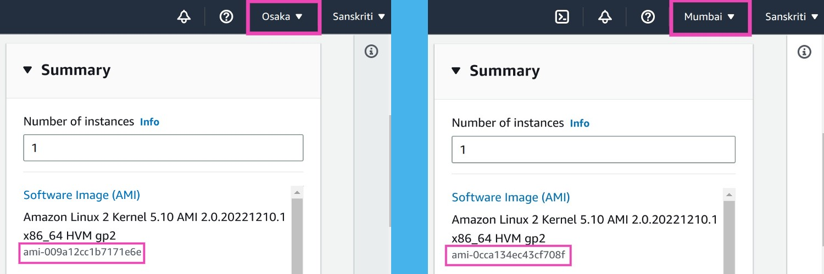

provider "aws"{
region = "ap-south-1"
access_key = "abc"
secret_key = "xyz"
}

resource "aws_instance" "test-ec2-instance"{
ami = "ami-0cca134ec43cf708f" #Image id for the ap-south-1 region
}

Select an instance type that meets your computing, memory, networking, or storage needs. I will use the type t2.micro.
provider "aws"{
region = "ap-south-1"
access_key = "abc"
secret_key = "xyz"
}

resource "aws_instance" "test-ec2-instance"{
ami = "ami-0cca134ec43cf708f" #Image id for the ap-south-1 region
instance_type = "t2.micro"
}

Change the current directory to where the launchEC2.tf file resides.
Execute terraform init command. This command will initialize the working directory containing Terraform configuration files and install any required plugins. It reads your configuration and identifies that you will be working with the provider of AWS. Now it will go ahead and start downloading the AWS related terraform plugins. As you can see below, it is installing AWS-related plugins.
terraform init
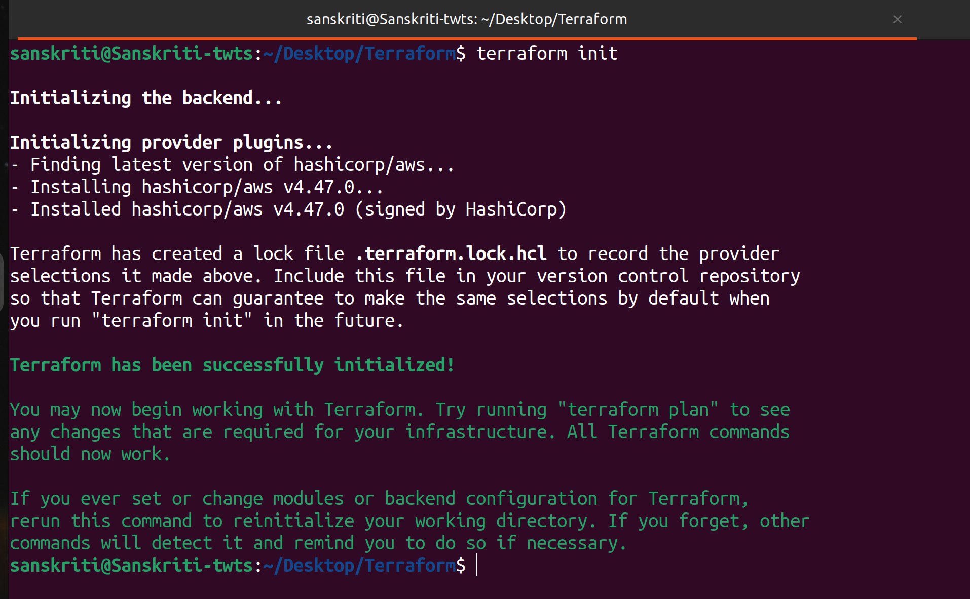

Plugin installation isn't the only thing the terraform init command does. To learn more about it, check out this well-written and informative blog on spacelift by Jack Roper about this command.
Execute the terraform plan command to see the infrastructure plan. You can make changes if required.
To delete the instance that we just created, execute the following command. Just mention the resource, i.e., aws_instance, and its name, i.e., test-ec2-instance, in the terraform destroy command.
Execute the command below:
terraform destroy -target=aws_instance.test-ec2-instance
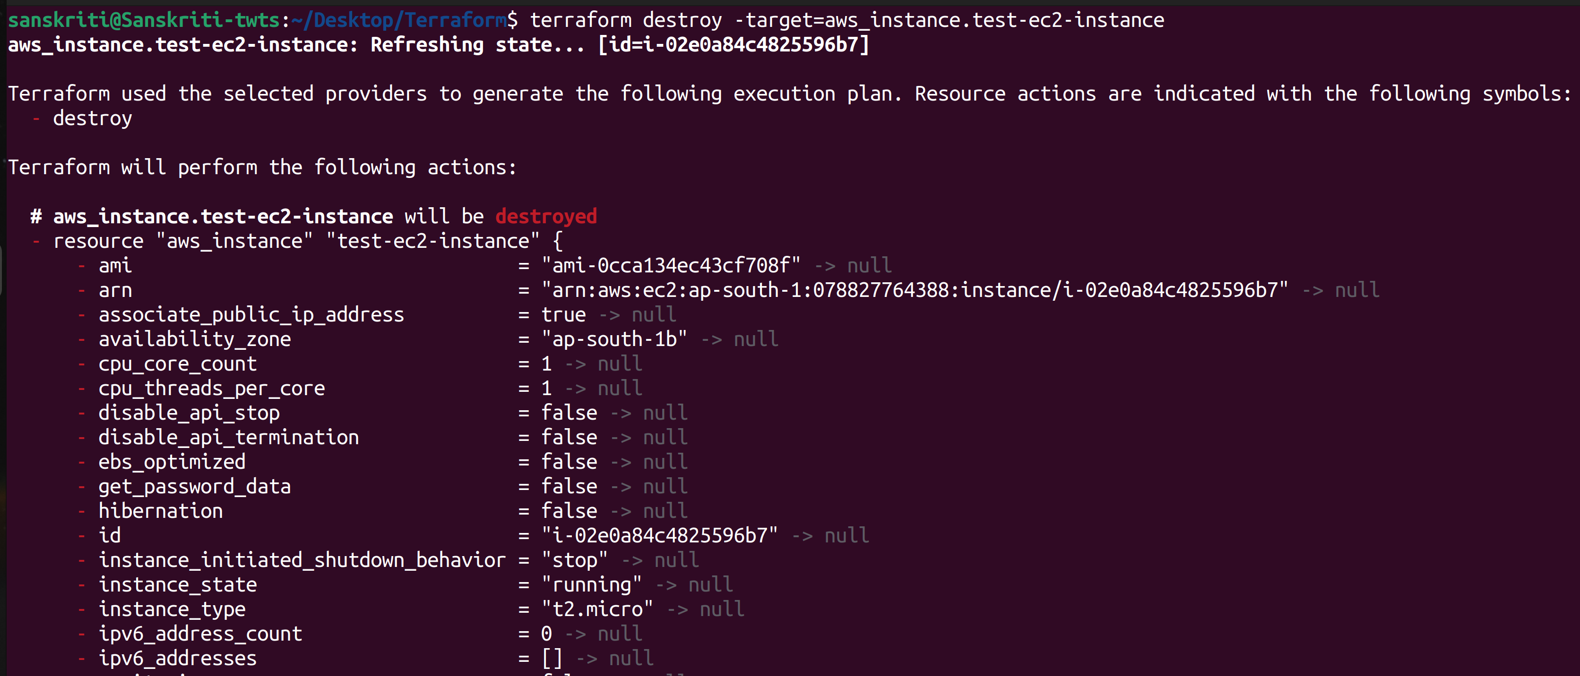

Enter yes.
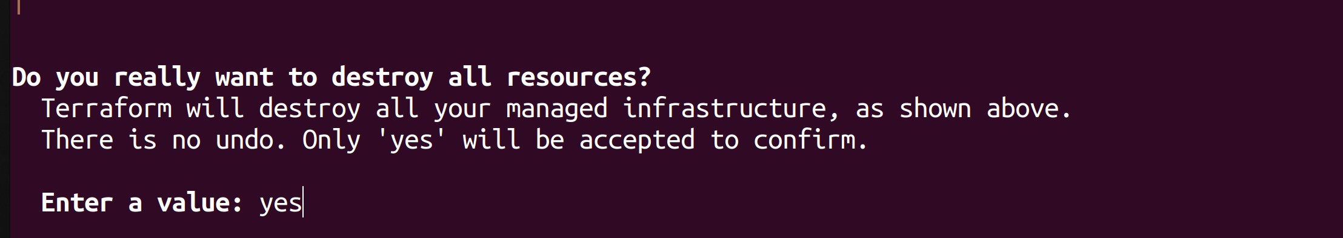

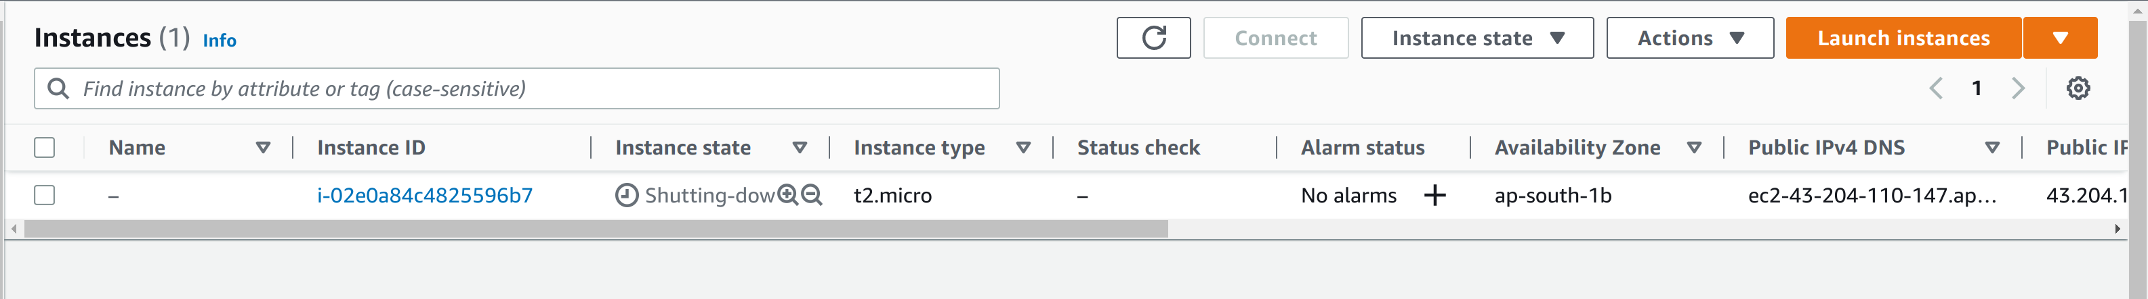

The instance got deleted!
